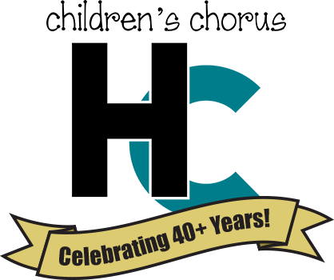
HCCC EMERGENCY INFO 2023 – 2024

This completed form must be returned by the first rehearsal.
(It is fine to email or text a picture of this form)

Chorister’s Name ________________________________________________

In case of emergency during rehearsals or performances, please contact:

____________________________________________ ________________________
NAME PHONE

____________________________________________ ________________________
NAME PHONE

Doctor:

____________________________________________ ________________________
NAME PHONE

Preferred Hospital:

____________________________________________ ________________________
NAME PHONE

Allergies or Medical Concerns:

My permission for my child’s picture/name to be shown:

Logan Daily News _____ yes _____ no
Logan-Hocking Times _____ yes _____ no
HCCC website _____ yes _____ no
HCCC Facebook page _____ yes _____ no
HCCC Instagram _____ yes _____ no

___________________________________________ __________
PARENT/GUARDIAN NAME DATE

